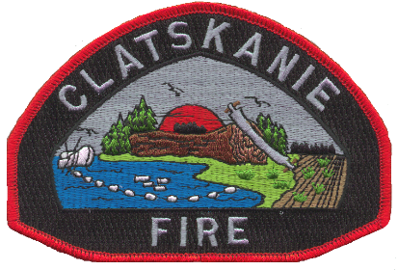

# **Clatskanie Rural Fire Protection District**

PO Box 807 / 280 SE Third St. Clatskanie, OR 97016

Phone (503) 728-2025 Fax (503) 728-4388 Email ssharek@clatskaniefire.org

**Wednesday, May 14, 2025**

***Regular Board Meeting Agenda immediately following Budget Committee Meeting***

**Call to Order / Pledge of Allegiance**

**Board Business:**

1. Roll call of Directors
2. Pictures of Board Members for board at the station – still need Keyser, Gibson, Mellinger and Stadelman
3. Chief Holsey’s 90 day performance evaluation – Executive Session
4. Tour of Main Station

**Comments from Visitors (allowed three minutes each.)**

None Scheduled.

**Consent Agenda**

1. Approval of Previous Meeting Minutes (March & April Meeting Minutes)
2. Approval of Financial Reports as presented.
3. Approval of Check Sequences, credit card, and Totals (see check approval letter)

**Old Business**

1. Main Station
   1. Generator Project Update – Rick/Chief Holsey
   2. Update on Emergency Fuel Tank project – Rick
2. Overlund Funds
3. Port Building Agreement

**New Business**

1. Completion of Radios and Comms project

**Fire Chiefs’ Report – Chief Holsey**

1. DO Hiring Process Update
2. Updated Civil Service List for FF/Paramedic position(s)
3. ASA – Update

**Assistant Chief’s Report – Chief Thorp**

1. Community Service Recap
2. Easter Egg Hunt
3. Health and Safety Fair
4. Monastery 1st Aid and CPR class(es)

**Volunteer Report Grady Tift**

Volunteer Academy Update(s)

**Comments from Directors**

**Executive Session (if needed)**

*192.660(2)(a) - To consider the employment of a public officer, employee, staff member or individual agent.* ***OR***

*192.660(2)(i)To review and evaluate the employment-related performance of the Chief Executive Officer(s) of any public body, a public officer, employee or staff member who does not request an open hearing.*

*192.660(2)(h) – To consult with counsel concerning the legal rights and duties of a public body with regard to current litigation or litigation likely to be filed.*

**Upcoming Meetings and Events of interest**

Board Workshop June 18th

Board Meeting June 18th (Budget Hearing)

***Workshop Board Meeting Agenda***

***No workshop, budget committee meeting at 6:00pm***

Pursuant to ORS 192.640(1), the Board of Directors of Clatskanie RFPD reserves the right to consider and discuss, in either open session or Executive Session, additional subjects which may arise after the agenda is published.